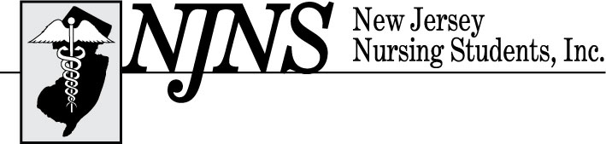

Follow the Yellow Brick Road: Finding Your Secret to Success in Nursing
73rd Annual Convention – Thursday, February 20, 2025
Resorts Casino 1133 Boardwalk, Atlantic City, NJ 08401
Convention Sponsorship Form

NJNS will provide complimentary publicity and recognition in our online convention program, on our website, and in our post convention newsletter, the Pulsebeat, which is sent to all New Jersey nursing students statewide.

Please indicate your selection(s) by placing a check mark in the appropriate boxes.

- Platinum Sponsor ($10,000)
- Gold Sponsor ($5,000)
- Silver Sponsor ($2,500)
- Bronze Sponsor ($1,000)
- Tote Bags (subject to cost, minimum of $7,000)
- Keynote Speaker ($5,000)
- Name Badges ($3,500)
- Deans and Directors Luncheon ($2,500)
- Decorations ($1,000)
- Entertainment ($1,000)
- Giveaways ($250)
- Door Prizes ($250)
- Scholarship Donation (Amount: $______)

Name of Donor: ____________________________________________________________
Address: __________________________________________________________________
Contact Person: __________________________ Phone Number: _______________
Email Address: __________________________ Fax Number: _________________

- If you donate $5,000 or more, your exhibitor fee is waived!
- If you are an exhibitor and a sponsor, your exhibit booth will be in a prime location.
- Donations received by February 5, 2025, are guaranteed recognition in the convention program.
- Please make all checks payable to New Jersey Nursing Students, Inc.
- Please return completed application with your check or money order to

New Jersey Nursing Students, Inc.
Attn: Regina Adams, BSN, RN, CNOR
1479 Pennington Road
Trenton, NJ 08618-2694

Questions, please contact Regina Adams, MSN, RN, CNOR via e-mail at staff @njnsinc.org or
call (609) 883-5335

Thank you for supporting New Jersey Nursing Students, Inc.

