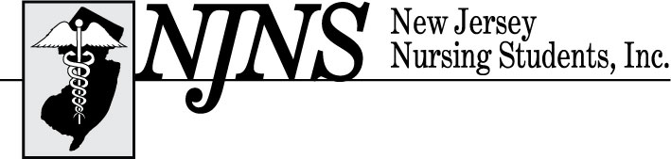

Follow the Yellow Brick Road: Finding Your Secret to Success in Nursing
73rd Annual Convention – Thursday, February 20, 2025
Resorts Casino 1133 Boardwalk, Atlantic City, NJ 08401
APPLICATION FOR EXHIBITOR SPACE

The Exhibit Hall at the New Jersey Nursing Students, Inc (NJNS) Annual Convention will be open for one day, Thursday, February 20, 2025. Setup will be Wednesday, February 19, 2025 from 5:00pm-8:00pm (times are tentative and subject to change). Exhibitor listing will be available on the NJNS website www.njnsinc.org and exhibitor information will be printed in the NJNS newsletter, Pulsebeat. Exclusive NJNS convention All reservations must be made, modified, or canceled individually through Hotel's Reservation Department by calling 833-441-1301 and referring to Group VNJNS25 or via unique group web-link (Below). Room rates are $59. Please make reservation by 2/14/2024 at 5pm
Weblink below:
https://resortsac.book.pegsbe.com/promo?propertyCode=ACYRSC&offerCode=VNJNS25
Exhibit space includes
- One (1) six foot table with linen table top
- Two (2) chairs
- Room lighting and maintenance (additional electrical service available for additional charge)
- Waste basket
- Complimentary continental breakfast and lunch will be served on Thursday, February 20, 2025
Exhibitor booth fees:
- $850.00 exhibit fee per booth (if contract and payment are received by February 5, 2025) and $950.00 exhibit fee per booth (if contract and payment are received after
February 5za, 2025).
- All booths are assigned on a first come first serve basis with a maximum of two (2) exhibitors per booth. A fifty-dollar ($50) fee will be incurred for each additional exhibitor.
- Exhibitors who are convention sponsors will have a prime exhibit booth location.
- No refunds; no exceptions.

CONTRACT FOR EXHIBITOR SPACE
Our organization would like to reserve an exhibit booth(s) for the 73rd Annual New Jersey Nursing Students, Inc. (NJNS) Convention. By signing this agreement, I agree that I will maintain the booth for the duration of the exhibit hall hours on Thursday only. I understand that the cost of each booth is $850.00 (if exhibitor contract and payment are received by 2/5/25),
Please provide a basket to be given away in the exhibit hall
Name of organization: ___________________________________________________________
Address: ______________________________________________________________________
City: __________________________________State:________________Zip:________________
Phone number: _______________________ Fax number: _______________________________
Email Address: _________________________________________________________________
Number of booth(s) to reserve @ $850.00 each_______________ (if received by February 5, 2025)
1.______________________________________________________________________
2.______________________________________________________________________
Method of Payment:
□ Check, make payable to New Jersey Nursing Students, Inc.
□ Money Order
□ VISA
□ Master Card
(NJNS assesses a $35.00 administrative charge for all returned checks.)
Name as it appears on the credit card______________________________________________________________ (please print or type) Credit Card # _________________________________________Exp. Date _________________ Total $_______________ Authorized Credit Card Signature _______________________________ (In order to process credit card, we need an authorized signature.)

Please return completed contract with payment to:
New Jersey Nursing Students, Inc. (NJNS)
Attn: Regina Adams, MSN, RN, CNOR
1479 Pennington Road, Trenton, NJ 08618
or fax it to (609)883-5343.
Questions, please contact Regina Adams, MSN, RN, CNOR at staff@njnsinc.org or (609)883-5335.
THANK YOU IN ADVANCE FOR SUPPORTING NEW JERSEY NURSING STUDENTS, INC.

Please make all checks payable to New Jersey Nursing Students, Inc.
Please return completed application with your check or money order to:
New Jersey Nursing Students, Inc.
Attn: Regina Adams, MSN, RN, CNOR
1479 Pennington Road
Trenton, NJ 08618-2694
Questions, please contact Regina Adams, MSN, RN, CNOR via e-mail at staff@njnsinc.org or call (609)883-5335

